Earth & Space Science Name:__________________________________
UNIT: Surface Processes Date: __________________ PD: ____________

LAB #______

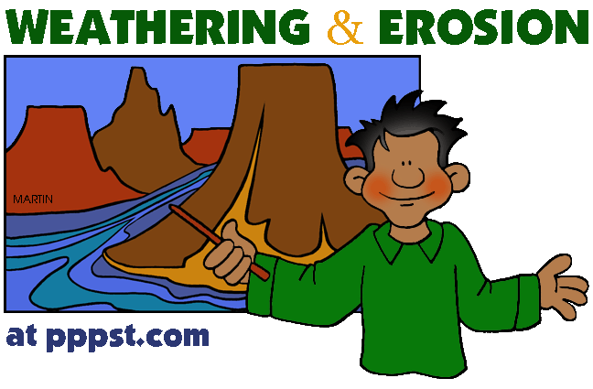
INTRODUCTION:
You will be assigned lab partners today and move throughout different workstations. There will be a given amount of time to do each station’s activity.

PROCEDURE:
1. There are 8 total stations for this double period lab. You will work on these stations over 2 periods. Each station will be 5 minutes long. Your group will start at the station with the same number as your group.

2. Follow the directions and answer the questions that correspond with the station.

3. When time is called, move on to the next station.

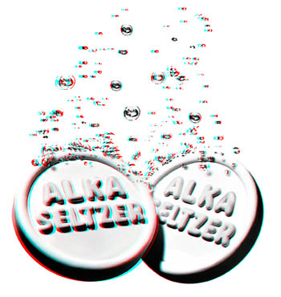
STATION 1: Crushed by You!
MATERIALS:
2 Alka Seltzer tablets
2 Cups of water
2 stop watches or use of cell phones to record times.

DIRECTIONS:
1. Fill up each cup with tap water.
2. Open the Alka Seltzer package.
3. Take one tablet out and put it aside.
4. Leave one tablet in the package and using a pen/hand, crush the tablet in the package.
5. Clear the stop watches, dump the solid tablet into 1 cup and dump the crushed tablet into the other cup.
6. Begin timing each cup and stop the timer once the tablet has completely dissolved.
7. Record the data.
8. Dump out the cups.
9. Answer the questions.

DATA:
SOLID TABLET’S DISSOLVING TIME | CRUSHED TABLET’S DISSOLVING TIME

QUESTIONS:

1. Which cup had the fastest weathering?

2. Explain why tablet had the fastest weathering:

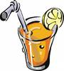
3. It is a very hot dry day on Long Island, and you are offered a glass of lemonade. You have the option of ice cubes or crushed ice for your drink.

a. Which type of ice would you select?

b. Explain why you made this choice:
STATION 2: Drop that Sediment!
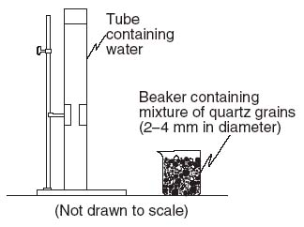
MATERIALS:
2 Vertical tubes full of water
2 trays of different sediment sizes: large and small
2 stop watches or cell phones to record times.

DIRECTIONS:
1. Assign each partner a column and a stop watch.
2. For each column, you will only use 1 size bead.
3. One at a time, you will drop a bead into the cylinder and time its descent from the top tape line until the bottom type line.
4. Record the time it took the sediment to fall.
5. Do this for each bead size 3 times.
6. Find the average of each bead size’s settling time.
7. Answer the questions.

DATA:
TRIALS | LARGE BEAD SIZE | SMALL BEAD SIZE
TRIAL 1
TRIAL 2
TRIAL 3
AVERAGE TIME

QUESTIONS:
1. Which bead size dropped with the higher velocity?

2. Explain why this bead size was faster to drop:

3. If you have a bag of mixed sized jelly beans, which size do you think will be found on the bottom of the bag?

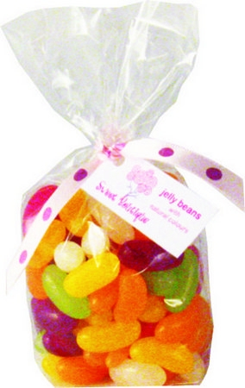

4. Explain why you think this size will be found on the bottom:


STATION 3: OBSERVATION/INFERENCE A
MATERIALS:
3 weathering images

DIRECTIONS:
1. Using each photograph, answer the questions that correspond to each photograph.
2. Once you are done with the photograph, please put it back on the desk.

PHOTOGRAPH 1:
1. Thinking back to our classroom discussion, what is the name of the object in the photograph?

2. Which of the following images is the “before” photo?

3. Describe what has happened to this object:

4. Why do you think this happened to the object?

PHOTOGRAPH 2:
1. Describe the environment in the photograph:

2. What natural disaster is captured in this photo?

3. What type of weathering is this?

4. Why is this dangerous for humans to encounter?


PHOTOGRAPH 3
1. What object is in this photograph?

2. Describe what happened to this object:

3. What type of weathering is this?

4. What could its owner have done to prevent this from happening?
STATION 4: Weathering HOT or NOT?!?
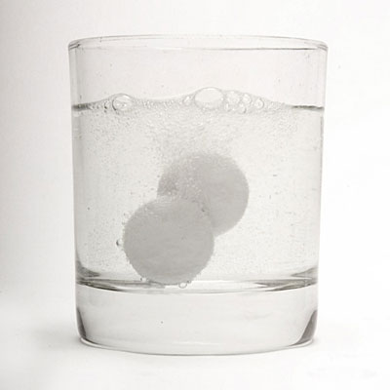
MATERIALS:
2 Alka Seltzer tablets
2 Cups
2 stop watches or cell phone to record times.
1 hot pot of water (be careful)
1 cup of room temperature water

DIRECTIONS:
1. Fill up each labeled cup. One with tap water, the other with hot water (be careful)
2. Open the Alka Seltzer package.
3. Take both tablets out whole.
4. Drop 1 tablet in the room temperature cup and start timing.
5. Drop the second tablet in the hot cup and start timing.
6. Stop timing each cup once its tablet has fully dissolved.
7. Record the data.
8. Dump out the cups.
9. Answer the questions.

DATA:
ROOM TEMPERATURE CUP’S DISSOLVING TIME | HOT TEMPERATURE CUP’S DISSOLVING TIME

QUESTIONS:

1. Which cup had the fastest weathering?

2. Explain why this temperature had the fastest weathering:

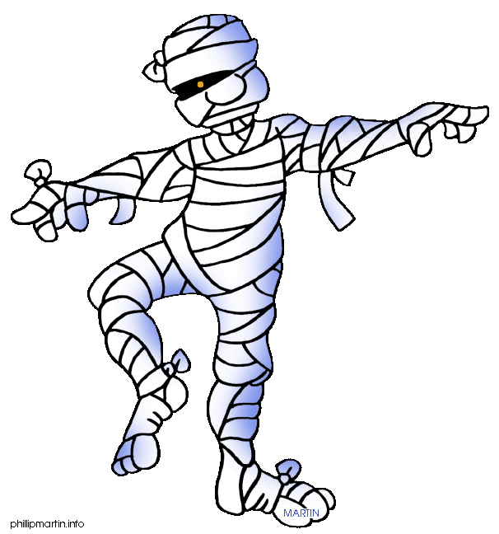
3. What would happen to a mummy’s body from the desert if it was moved to a museum located in the Amazon?

4. Explain why you think this will happen to the mummy’s body:

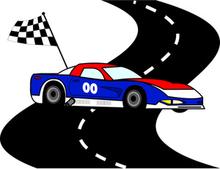
STATION 5: The Race is on!
MATERIALS:
2 wooden cars
2 different sloped ramps
2 stop watches or cell phone to record times.

DIRECTIONS:
1. Assign each partner a ramp and a stop watch.
2. Record the time it took the car to travel from the bottom of the ramp until the “finish line”.
3. Do this for each ramp 3 times.
4. Find the average of each ramp’s race time.
5. Answer the questions.

DATA:
RACES | HIGH SLOPE RAMP | LOW SLOPE RAMP
RACE 1
RACE 2
RACE 3
AVERAGE TIME

QUESTIONS:

1. Which ramp had the higher velocity?

2. Explain why this ramp was faster in the race:

3. If you owned a glass plate factory, which ramp would you want to load your glass plates into the trucks?

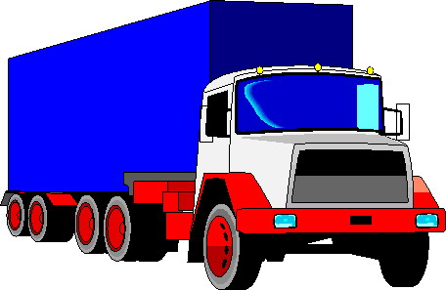

4. Explain why you selected this ramp type:

STATION 6: OBSERVATION/INFERENCE B
MATERIALS:
3 weathering images

DIRECTIONS:
1. Using each photograph, answer the questions that correspond to each photograph.
2. Once you are done with the photograph, please put it back on the desk.
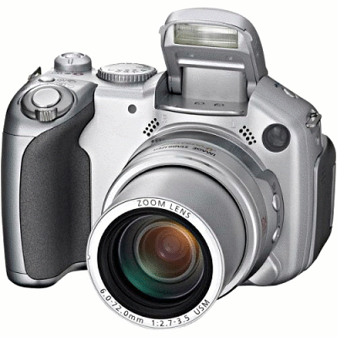
PHOTOGRAPH 4:
1. Describe what is happening to the rock in the photograph:

2. Explain why this is happening:

3. Explain 2 ways planting trees right next to a sidewalk could be dangerous to humans:
1. 2.

4. What type of weathering is this?

PHOTOGRAPH 5:
1. What are the two main features of the cave in the photograph called?
1. 2.

2. Which type of weathering is this?

3. What is the main rock TYPE that causes this feature?

4. What is the main rock’s NAME that creates these caves?

5. What is the main MINERAL’S NAME in this rock?

PHOTOGRAPH 6:
1. What is the name for this dangerous feature in the road?

2. Describe what happened to create this feature:

3. What type of weathering is this?

4. What kind of temperature and humidity do you need to create this feature?
STATION 7: VOCABULARY/RELATIONSHIPS
MATERIALS:
Textbooks/lap tops

DIRECTIONS:
1. Using your notes and books, define the vocabulary words.
2. Using your knowledge regarding weathering, draw and label each relationship trend.
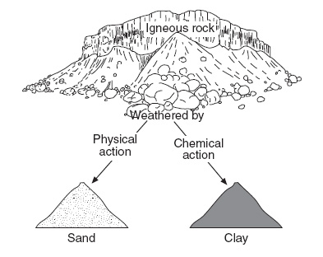
PART A: VOCABULARY:

1. Weathering:

2. Soil:

3. Velocity:

4. Erosion:

5. Deposition:

PART B: TRENDS
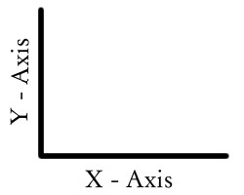
a. Particle Size vs Rate of Weathering

RELATIONSHIP TYPE: ______________________
Draw the relationship on the graph
PARTICLE SIZE


b. Amount of Moisture vs Rate of Weathering

RELATIONSHIP TYPE: ______________________
Draw the relationship on the graph

MOISTURE AMOUNT

c. Amount of Surface Area vs Rate of Weathering:

RELATIONSHIP TYPE: ______________________
Draw the relationship on the graph
SURFACE AREA

STATION 8: OBSERVATION/INFERENCE C
MATERIALS:
3 weathering images

DIRECTIONS:
1. Using each photograph, answer the questions that correspond to each photograph.
2. Once you are done with the photograph, please put it back on the desk.

PHOTOGRAPH 7:
1. Thinking back to our classroom discussion, what is the name of the green material in the photo?

2. What material was this green substance originally?

3. Describe what has happened to this object to change it:

4. What type of weathering is this?

PHOTOGRAPH 8:
1. What is the name for this dangerous feature in the land?

2. Describe what happened to create this feature:

3. What type of weathering is this?

4. What kind of temperature and humidity do you need to create this feature?


PHOTOGRAPH 9
1. What happened to the mountain side?

2. Describe the effects on the city:

3. What type of weathering is this?

4. What could a city resident do to prevent property damage or personal injury from this event?

